**Multi- Domain Chat-Bot – Milestone 2 Report**

1. **INTRODUCTION**

Before deep-learning stepped into the field of chat-bots, there were traditional techniques using tf-idf, information retrieval etc. to output appropriate responses for the given context. These bots do handle different domains intelligently using techniques such as LDA, supervised multi-class classifier etc. Deep Learning generative methods is good in generating new unique sentences. But, the traditional seq2seq is incapable of responding differently for different domains. Domain knowledge is very important as a similar context can be present in two different domains. And the responses to these domains will be completely different. Also, many a times a user gets engaged in a conversion, and thus we can safely assume that there would a smooth transition of domain between the user and the chat bot over the course of a conversation. Our project takes help of seq2seq model and make it smarter by responding to different domains appropriately.

1. **MODEL**

We trained three separate Seq2Seq models on three different domains with data extracted from reddit conversations. We did early stopping and checked if the answers are correlated. One thing to observe was that in the movie or gaming domain, we usually got single worded answer: E.g. “*What is your favorite movie ?” --> “Star wars”*. This came from the fact that people in reddit do type very short responses to the queries. Therefore, we expanded our dataset by extracting comments and replies from the post comment-reply level in the hope to get long responses from chat bot and kept responses greater than 5 words in length. It helped in generating longer sentences. Apart from this, we’ve built a classifier in order to detect the domain of the current dialogue. This model captures the tf-idf based features on the current utterances as well as incorporates previous domains as weights to decide the final domain. The idea is to trigger the seq2seq for the domain that the classifier predicts. Figure -1 summarizes our overall model.

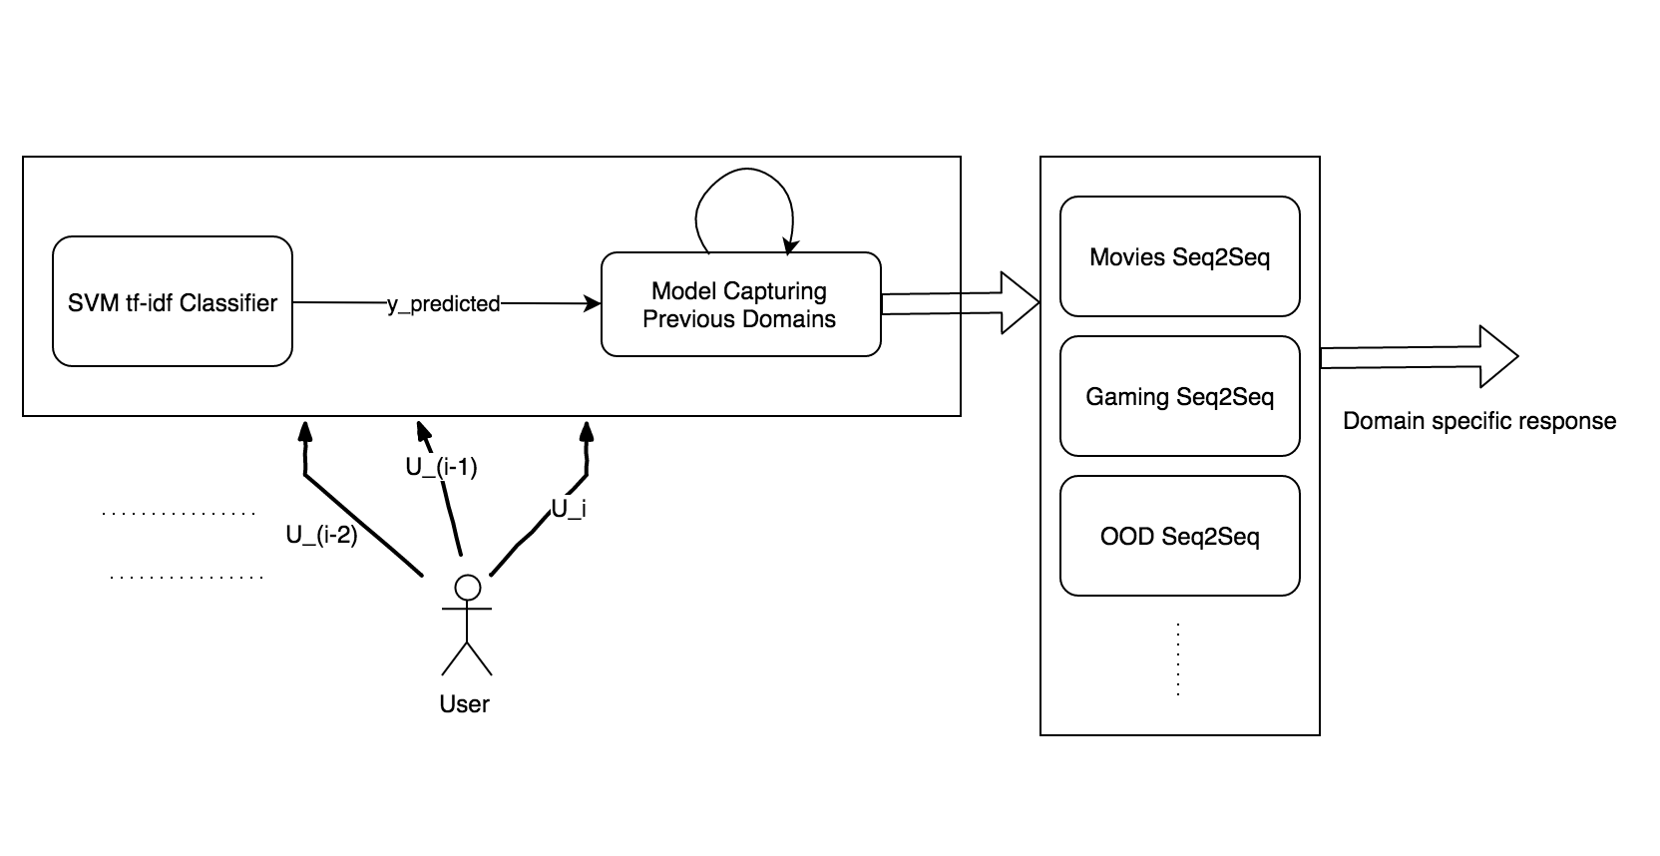

Figure – 1 : Sequence of the utterance during test time.

This is a scalable model as we need not to re-train our entire seq2seq models for incorporating new domain. We can easily train our new domain’s seq2seq separately and then plug in into our current model.

1. **DATASET**
2. **Training Data for Seq2Seq models**

The three domains are: Games, Movies and Social. For games and movies domain, we took dataset from Reddit forums. These data were downloaded from Google’s BigQuery. We labelled title/forum-query as a context and their comments as the responses. Also, to expand our data set and generate longer sentences, we extracted comment-reply pairs from same posts. For Social domain, we downloaded twitter conversation used in our previous homework.

1. **Training Data for tf-idf classifier model**

We used separate set of reddit data which was not used for training of seq2seq models. This individually gave accuracy of ~80% on test set.

1. **Training Data for model capturing previous domains**

We were not able to get any conversation data which does smooth switching between domains. Thus, we ended up making our own synthetic data using different conversions of reddit. We shuffled dialogues from different domains to create conversations of different length. This data was put to training the ensemble model.

1. **EXPERIMENTS**
2. **Seq2Seq**

We trained our seq2seq model till evaluation perplexity of ~10. We defined some of our initial sentences(context) and the correct responses to them were set as goals for these seq2seq models. Also, during this phase we observed that the utterances if swapped with the wrong domain was giving unwanted results. This further shows the effect of training separate domain specific models. Table-1 summarizes some of the utterances which were pre-decided.

|  |  |  |  |  |
| --- | --- | --- | --- | --- |
| Id. | Utterance | Intended Domain | Response by movie Domain | Response by gaming Domain |
| **1** | which is your favorite game | Gaming | The Man from UNCLE is a great one . | The Witcher 0 , battlefield 0 , and Fallout 0 |
| **2** | which is your favorite movie | Movie | The original Star Wars . | game ' s Sky . It ' s the only |
| **3** | i want to buy gta | Gaming | . | Save dark souls and dark souls 0 |
| **4** | let us play some multiplayer game | Gaming | This is the correct answer . | if that doesn ' t have a game like it |
| **5** | do you like brad pitt | Movie | I think that ' s the best | I don ' t know thanks . |

Table- 1

Notice how utterance 5 is responded as “I don’t know thanks” by the wrong(gaming) domain. Thus, it is very important to classify the domain correctly.